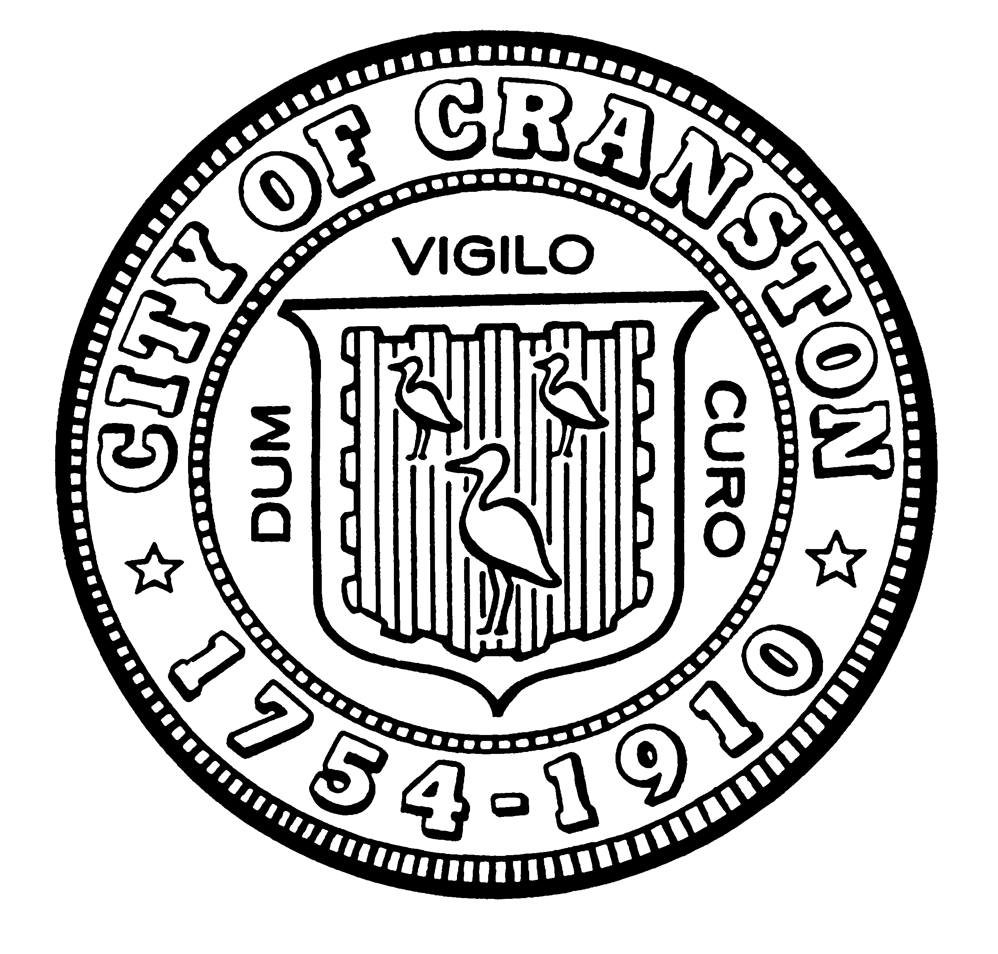

HOUSING COMMISSION

Annette Mann Bourne, Chair
Robert Santurri Jr, OneCranston Health Equity Zone, Vice Chair
Amy Rainone, Secretary
Ernest Tommasiello, Director, Department of Community Development
Jason Case
Kristina Brown
Joanne McGunagle, CCAP
Jason M. Pezzullo, Planning Director
Derik Tutt

WEDNESDAY MARCH 1, 2023 @ 5:30 P.M.
Cranston City Hall, 869 Park Avenue
3rd Floor Conference Room

MONTHLY MEETING AGENDA

- Approval of minutes of February 1, 2023 meeting (for vote)
- Election of officers (for vote)
- Presentation from OneCranston HEZ
- Review Councilman Donegan’s lead certificate ordinance (for discussion)
- New business (for discussion)

“Individuals requesting interpreter services for the hearing-impaired must notify the Office of the City Clerk at 461-1000 Ext. 3197 seventy-two (72) hours in advance of the hearing date.”

